**Review Worksheet Answers: Fossil Evidence 3 – Fluorine Dating, Phylogenetic Trees**

1: A range of fossil bones from different species were found in a cave. Describe how fluorine dating works and could be used to determine relative ages of the bones.

(4 marks)

*When fossils are exposed to ground water, fluorine in the water seeps into the bones (1). The longer a bone has been exposed, the more fluorine will be present (1). By measuring the fluorine in the bones in the cave, relative ages could be determined (1). The older bones will have more fluorine in them, and the more recent bones will have less (1).*

2: Would fluorine dating be useful to determine relative ages of fossils in different locations? Explain your answer.

(3 marks)

*No.(1) The amount of fluorine in ground water is different in different locations (1), so this dating method is only useful for comparing specimens from the same location (1).*

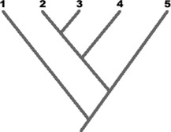3: Based on the phylogenetic tree shown, we can conclude that species 2 is most closely related to species:

A. 1

B. 3

C. 4

D. 5

E. 1 or 3

4: This tree diagram shows the evolution of land plants as indicated by fossil records.

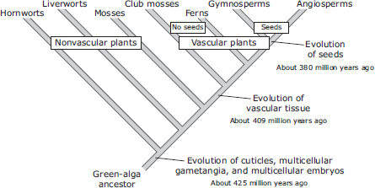

Which discovery would challenge the validity of this tree diagram?

1. A large aquatic vascular plant about 200 million years old.
2. A species of algae that has existed for less than one million years.
3. A moss species that has existed for less than 380 million years.
4. A fossil of a fern more than 425 million years old.

5: Use the following characteristics of these organisms to make a tree diagram. Remember that all organisms started with a common ancestor, so all phylogenetic tree diagrams should start from a single point and branch as they develop differing characteristics.

(1 mark)

|  |  |  |  |  |
| --- | --- | --- | --- | --- |
| Characteristics | Shark | Bullfrog | Kangaroo | Human |
| Vertebrae | X | X | X | X |
| Two pairs of  limbs |  | X | X | X |
| Mammary  Glands |  |  | X | X |
| Placenta |  |  |  | X |

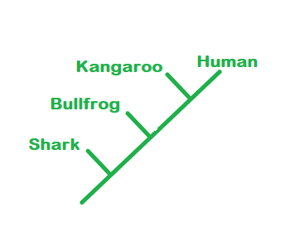

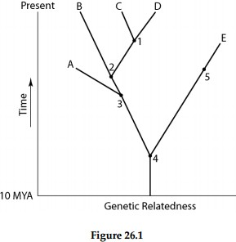6: A common ancestor for both species C and E could be at position number:

A) 1 B) 2 C) 3 D) 4 E) 5

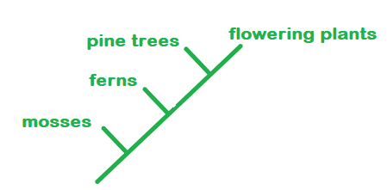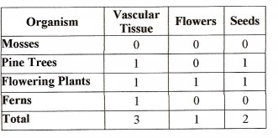7: Use the following data table to construct a tree diagram of the major plant groups below. The table shows which plants have the traits listed.

8: On a hot day, water is lost to the body due to sweating.  
  
Draw an annotated homeostatic feedback loop to show how fluid balance is maintained when water is lost. (15 marks out of 18 possible marks on key)

